**DAILY ONLINE ACTIVITIES SUMMARY**

|  |  |  |  |  |  |  |  |  |
| --- | --- | --- | --- | --- | --- | --- | --- | --- |
| **Date:** | **2/06/2020** | | | | | **Name:** | **POOJA D S** | |
| **Sem & Sec** | **4th SEM 'B' Section** | | | | | **USN:** | **4AL18CS056** | |
| **Online Test Summary** | | | | | | | | |
| **Subject** | |  | | | | | | |
| **Max. Marks** | | **30** | | **Score** | | |  | |
| **Certification Course Summary** | | | | | | | | |
| **Course** | **Computer Vision Essentials** | | | | | | | |
| **Certificate Provider** | | | **Great Learning Academy** | | **Duration** | | | **5.5 hour** |
| **Coding Challenges** | | | | | | | | |
| **Problem Statement:** A user will input two strings, and we find if one of the strings is a sub sequence of the other. Program prints “yes” if either the first string is a sub sequence of the second string or the second string is a sub sequence of the first string. Assume that, the length of the first string is smaller than or equal to the length of the second string. Assume that, the length of the first string is smaller than or equal to the length of the second string. | | | | | | | | |
| **Status: completed** | | | | | | | | |
| **Uploaded the report in Github** | | | | | **Yes** | | | |
| **If yes Repository name** | | | | | <https://github.com/dspooja/C-coding>  <https://github.com/dspooja/Java-coding> | | | |
| **Uploaded the report in slack** | | | | | **Yes** | | | |

Online Test Details: (Attach the snapshot and briefly write the report for the same)

Certification Course Details: (Attach the snapshot and briefly write the report for the same)

Coding Challenges Details: (Attach the snapshot and briefly write the report for the same)

CERTIFICATION COURSE DETAILS:

* As continuation of the **Computer Vision Essentials** online course
* **The concepts covered in Computer Vision Essentials are:**
* Introduction to Convolutions
* 2D convolution for Images
* Convolution - Forward
* Convolution – Backward

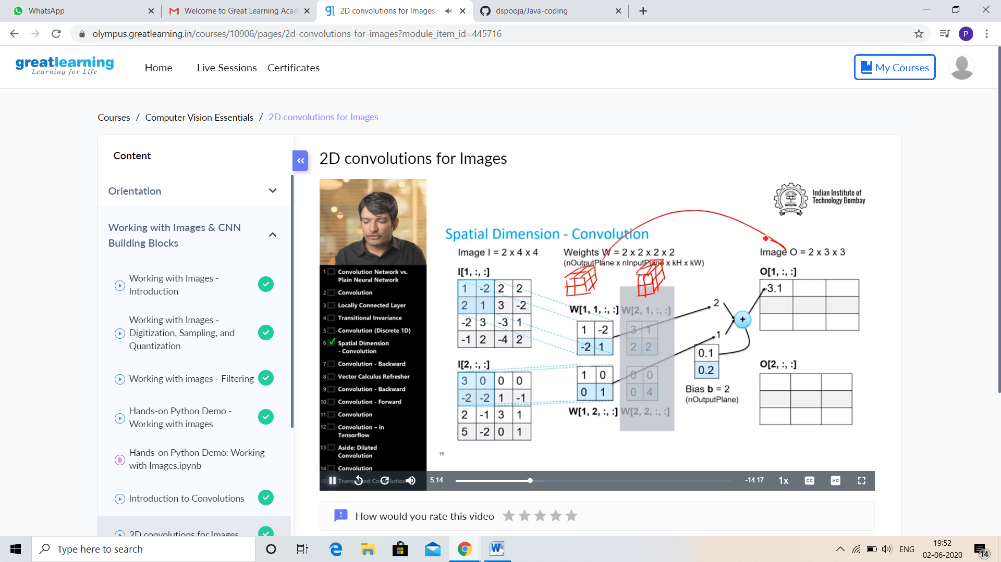

And today I complete the Robotic Process Automation, this is my certificate screen shot.

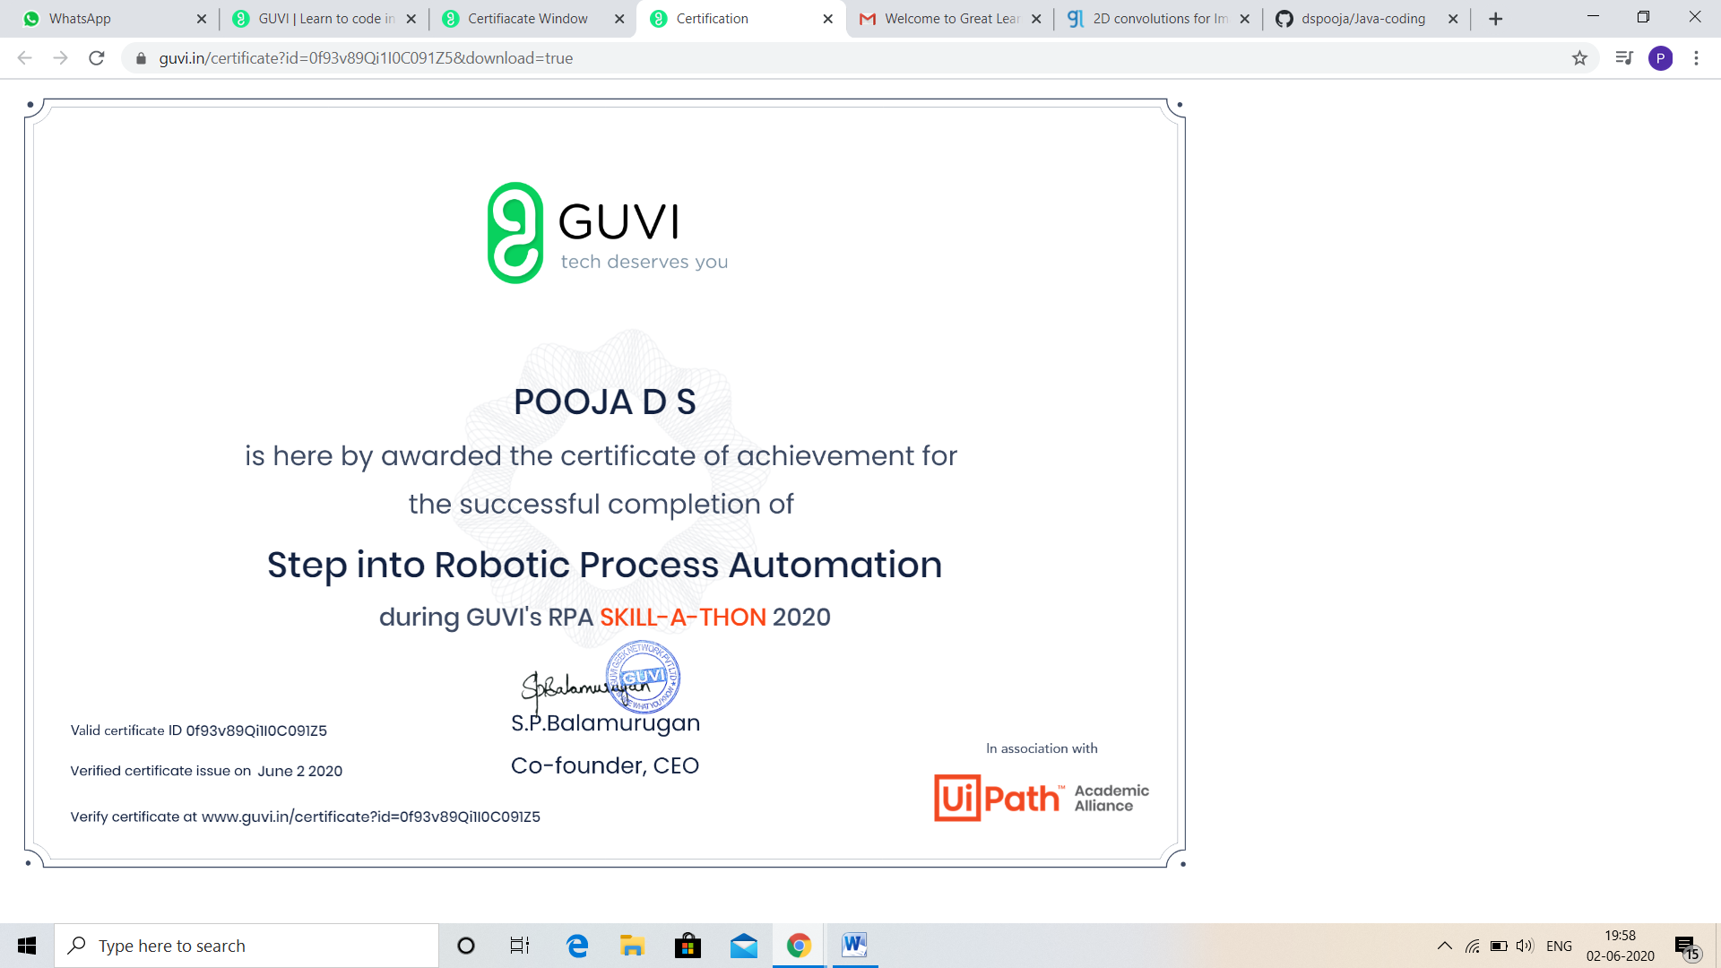

CODING CHALLENGES DETAILS:

Problem statement 1:

Given an array of positive integers. Write a C Program to find inversion count of array.

**Inversion Count:** For an array, inversion count indicates how far (or close) the array is from being sorted. If array is already sorted then inversion count is 0. If array is sorted in reverse order that inversion count is the maximum.  
Formally, two elements a[i] and a[j] form an inversion if a[i] > a[j] and i < j.   
**Input:**  
The first line of input contains an integer T denoting the number of test cases. The first line of each test case is N, the size of array. The second line of each test case contains N elements.  
**Output:**   
Print the inversion count of array.  
**Constraints:**  
1 ≤ T ≤ 100  
1 ≤ N ≤ 107  
1 ≤ C ≤ 1018  
**Example:  
Input:**  
1  
5  
2 4 1 3 5  
Output:  
3  
**Explanation:  
Testcase 1:** The sequence 2, 4, 1, 3, 5 has three inversions (2, 1), (4, 1), (4, 3).

Solution : Uploaded it in github

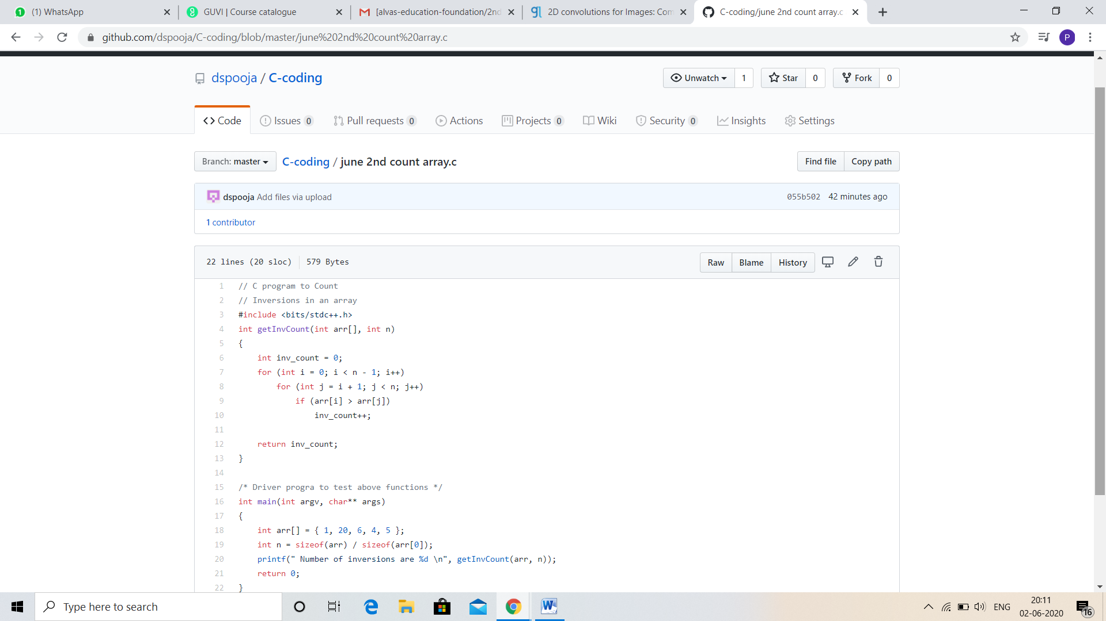

Problem statement 2:

|  |  |  |  |
| --- | --- | --- | --- |
| Write a Java program to find Perfect Sum Problem.  Given an array arr[] of integers and an integer K, the task is to print all subsets of the given array with the sum equal to the given target K.  **Examples:**  **Input:** arr[] = {5, 10, 12, 13, 15, 18}, K = 30 **Output:** {12, 18}, {5, 12, 13}, {5, 10, 15} **Explanation:** Subsets with sum 30 are: 12 + 18 = 30 5 + 12 + 13 = 30 5 + 10 + 15 = 30  Input: arr[] = {1, 2, 3, 4}, K = 5 Output: {2, 3}, {1, 4}  Solution: Uploaded in github. |  |  | https://mail.google.com/mail/u/0/images/cleardot.gif  https://mail.google.com/mail/u/0/images/cleardot.gif |
| Problem statement 3:  JAVA PROGRAM  Write a program in java, an array of integer data to be initialized. During the initialization, if a user enters a value other than integer value, then it will throw InputMismatchException exception. On the occurrence of such an exception, your program should print “You entered bad data.” If there is no such exception it will print the total sum of the array.  Solution: Uploaded in github. | | |